RETAIL BRAND REPORT
Prepared by: Jonathan W Dimock, ULXI · Date: August 27, 2026 · Status: DRAFT — for discussion

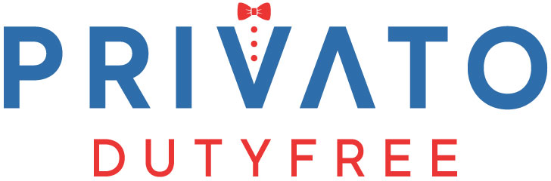
Retail Brand Report
Company Identification · Strategy · Competition · Partnerships

Index
1. Identification 3
2. Top Four Suggestions 4
2.1 Make the Existing Footprint Findable 4
2.2 Relaunch the App, Privato-Branded 4
2.3 Lead the Retail Brand with What Competitors Cannot Easily Match 4
2.4 Open the Partnership Channel — It Is Already Built 4
3. Company and Ownership 5
4. Business Model and Network 6
5. Brands — and What to Lead With 7
6. Competition — Wider Than Duty Free 8
7. Partnership Opportunities 9
8. Digital Presence and the App 10
9. Data Still to Collect 11
10. Method and Companion Materials 12
11. App and Website Concepts 13
11.1 App Concept — Home, Collection, Delivery, and Reserve 13
11.2 Website Concept — Homepage and the Private Atelier 13
12. Sources and Citations 15
12.1 Company Record and Trade Press 15
12.2 Company Web Properties 15
12.3 Aviation and Market Data 15
12.4 Partnership Candidates 16
12.5 Method Sources (Workbook Data Columns) 16

1. Identification
Trade name | Privato Duty Free (the customer-facing retail brand)
Legal entity | Bulldog Duty Free Inc. — Florida for-profit corporation, doing business as Privato Duty Free
State record | Florida document P17000017404 · incorporated February 22, 2017 · active, annual reports filed through 2025 (officer list needs additional confirmation on Sunbiz)
Stated founding | 2016 (company statements; one year ahead of the incorporation date)
Headquarters | 11 SW 12th Avenue, Suite 106, Dania Beach, FL 33004 — corporate office and warehouse
Phones | (954) 923-9595 · toll-free (833) 326-3889
Email | info@bulldogdutyfree.com · marco@bulldogdutyfree.com
Principal | Marco Antonio Arilli — founder, managing director, and president; roughly thirty years in duty-free and travel retail (JC Penney, LVMH/Starboard Cruise Services, DFS at Miami International, DFASS/3Sixty); Western Michigan University
Other officers | One additional director appears on the state record under a name that needs additional confirmation
Business | Duty-free and duty-paid luxury retail for private-jet passengers at FBO terminals — app pre-order, in-lounge ordering, and delivery to the aircraft before departure
Footprint | 34 airport markets · 105–112 FBO points of sale · 18 bonded warehouses. Client-side indication: ~240–250 operating and near-term locations; trade press reports a growth target of ~240 additional (about 350 at full build-out) — reconcile with the client's internal list
Customers | Private-jet passengers — owners, charter and fractional flyers (NetJets- and Wheels Up-type clientele)
Key partner | Streiffer Duty Free (Millett family, New Orleans, est. 1896) — bonded distribution of spirits, wine, champagne, and tobacco
Web properties | privatodutyfree.com (main store) · a separate liquor storefront · bulldogdutyfree.com (corporate; currently shows no content)
Mobile app | iOS app released 2022 under the Bulldog name, currently offline; no Android listing was found

2. Top Four Suggestions
The wholesale engine is strong — more than a hundred points of sale, a bonded supply chain, and vendor agreements many retailers cannot get. The retail layer is the opportunity, and these four moves build it in order.
2.1 Make the Existing Footprint Findable
Privato is already at more than a hundred FBOs, but a passenger who searches for it finds almost nothing. The audit found no claimed Privato map listings across the network — including every priority airport market reviewed — no mentions on the FBO amenity pages, and the listings that do exist carry the corporate Bulldog name rather than Privato. Claiming the map listings, unifying every public touchpoint under the Privato name, and getting amenity-page mentions from the FBO hosts costs little and makes the service that is already on the field visible to the customer standing in it. First step: claim the Google Business Profiles for the top ten markets and draft a one-paragraph amenity blurb the FBOs can paste.
2.2 Relaunch the App, Privato-Branded
The pre-order flow is the retail product — ordered ahead, delivered to the aircraft before departure — and today it has no working app behind it: the iOS listing from 2022 is offline and no Android listing was found. A Privato-branded relaunch turns the strongest part of the business model back into something a customer can hold, and the 2026 concept screens already show what it should feel like. First step: decide relaunch scope and pause the app references on the website until it is live.
2.3 Lead the Retail Brand with What Competitors Cannot Easily Match
The workbook surfaces several distinct forms of differentiation, not one: high-value agreements with little competitor presence (The Last Drop is the clearest pure scarcity lead), allocation-constrained bottles the bonded chain can source (Weller 12, Blanton's), emerging brands with launch potential (Cairlinn Bay, Lucyd, Casa 1910), and category stories few match (Valmont, PXG). The saturated favorites (Ray-Ban, LEGO, Coach, Johnnie Walker) still sell, but as convenience: the customer needs it now, at the aircraft, and availability is the pitch. Build the storefront and the campaigns around those stories — and consolidate the three separate web storefronts into one catalog under one brand while doing it. First step: a hero collection of the ten highest-scoring pieces.
2.4 Open the Partnership Channel — It Is Already Built
The private-aviation ecosystem runs formal partner programs Privato can simply apply to: Flexjet's Partnership Guide, Jet Linx Elevated Lifestyle, Sentient's annual Benefits Guide, NetJets' partner exclusives, Pinehurst's Brand Partners program, USGA hospitality — and JSX, the semi-private carrier flying from private terminals in ten Privato markets with a daily Cabo route where true duty-free applies and no retail partner on board today. In-flight caterers are the sleeper channel — their trucks are already cleared to the ramp daily and can carry Privato fulfillment before a market has staff. The Pinehurst weekend that lifted sales 208% is the proof this model converts. First step: applications to the three partner programs with published intake processes.

3. Company and Ownership
Privato Duty Free is the retail brand of Bulldog Duty Free Inc., a Florida corporation founded by Marco Antonio Arilli and incorporated in February 2017 (the company dates itself to 2016). Arilli is the only principal who appears publicly: roughly thirty years in duty-free and travel retail, including merchandise leadership at LVMH/Starboard Cruise Services, purchasing for twenty-two DFS duty-free stores at Miami International, and executive roles at DFASS, now 3Sixty. The state record lists one additional director whose name needs additional confirmation, and ownership percentages are not public. No parent company, outside investors, acquisitions, or name changes appear anywhere in the record — Bulldog to Privato is a branding layer, not a corporate change.
The company presents two names to the world today: Bulldog on the corporate record, the Apple Maps listing, the Rado authorized-retailer listing, and the 2022 app, and Privato on the storefront and in the press. Unifying the public-facing identity under Privato is part of suggestion 2.1.

4. Business Model and Network
The model is a logistics chain rather than retail square footage: bonded warehouses feed pre-orders placed through the app or in FBO lounges, and orders are delivered to the aircraft before departure. Orders placed two to forty-eight hours out pull from the local warehouse; beyond forty-eight hours, from nationwide stock. Duty-free pricing legally applies to international departures only, which means domestic legs — most US private-jet traffic — buy duty-paid at effectively normal retail. That is exactly why the competitive set below includes ordinary retail, and why service, scarcity, and delivery, rather than the duty-free price alone, have to carry the brand.
The documented network: 105 points of sale listed by the company across 31 airport markets, plus Panama City (its number-three seller almost immediately after opening), Burbank, and the permanent Pinehurst store from trade coverage — 108 documented retail points, plus the Dania Beach headquarters and 18 bonded warehouses. Three numbers must be kept separate: 108 retail points are publicly documented; the client side indicates a network of roughly 240–250 operating and near-term locations — against that indication, roughly 132 points, more than half the network, are not yet visible anywhere public; and trade press separately reports a growth target of roughly 240 additional locations, which would imply about 350 at full build-out. Each location also delivers to what the company describes as three to more than twenty neighboring FBOs, which is how a staffed network of about 112 points serves a far larger map. The client's internal location list is the one document that closes the count.
Expansion runway: of the 2,442 US airports the FAA lists as selling jet fuel (heliports excluded — fuel sales are the proxy for the services and support a retail point needs), 52 are airports Privato already serves, 371 sit within fifty miles of one — reachable from existing warehouses — and 802 within one hundred miles. The full list, with distance to the nearest Privato location, is the Jet Fuel Airports tab of the companion workbook.

5. Brands — and What to Lead With
The research identified 163 brands on Privato's own properties (one, Omega, rests on homepage imagery and is flagged for verification), 13 more in press coverage, and 15 groups of likely-but-unpublished brands reachable through suppliers already on contract. Every brand is scored 0–100 in the companion workbook on prestige, vendor-agreement value, competitor saturation (measured against the tracked competitor set for its category), customer demand, and co-brand value, on one rule: the harder an agreement is to get, the more the one already in hand is worth.
What that scoring surfaces is several kinds of differentiation rather than one: The Last Drop is the clearest pure scarcity lead under the workbook's own rule (top agreement value, near-zero saturation); Weller 12 and Blanton's add allocation and availability appeal through the bonded chain; and Cairlinn Bay, Valmont, Casa 1910, PXG, and Lucyd give Privato distinctive category and launch stories even where their scores classify them as core range. The saturated favorites (Ray-Ban, LEGO, Coach, Johnnie Walker) stay in the range as convenience sellers — everyone stocks them, and customers still want them now, at the aircraft, which only the logistics chain can deliver. A third column scores what each brand gains from Privato: young, scarce brands (Cairlinn Bay, Lucyd, Casa 1910) get a US launch channel, which is negotiating leverage for exclusives and margin. The easiest new agreements run through existing supplier relationships: the Streiffer book (Diageo, Moët Hennessy, Sazerac lines), the Fossil Group license book, and the EssilorLuxottica book behind the existing Ray-Ban account.

6. Competition — Wider Than Duty Free
Within the competitive set reviewed, Privato stands alone as an app-first, nationwide warehouse-to-aircraft duty-free network. One duty-free rival shares the channel — Duty Free Holdings' Executive Retail Shops, which also delivers to aircraft from Miami and San Diego warehouses — and the traditional duty-free operators live in commercial terminals. But because most flights are domestic, the real competition is the retail the customer already uses:
- Price setters: Costco (gray-market Breitling and Omega, Dom Pérignon, Kirkland Scotch) and Jomashop (watches, sunglasses, and even Creed and La Mer, one search away from the cabin).
- The customer's defaults: Bucherer and Watches of Switzerland for watches; Saks, Neiman Marcus, Bloomingdale's, and Sephora for beauty; Sunglass Hut — owned by the same company that supplies Privato's Ray-Ban.
- Home-market bottle shops in exactly the FBO-heavy states: Spec's in Texas, Binny's in Chicagoland, ABC Fine Wine in Florida — spirits and cigars under one roof, with allocated-bottle programs of their own.
- Delivery: Total Wine same-day, ReserveBar, Instacart and Gopuff — to the house, not the hangar.
Where none of them can follow: delivery planeside on the customer's departure timeline, bonded duty-free fulfillment on international legs, allocated bottles sourced through the bonded supply chain, and a single basket spanning a watch, cigars, an allocated bourbon, skincare, and a LEGO set for the kids. That combination is the brand.

7. Partnership Opportunities
Thirty-seven named, non-competing candidates are cataloged on the Partnership Opportunities tab of the companion workbook, across seven categories: FBO networks and private terminals, charter and fractional operators, in-flight caterers, ground and hospitality, cards and concierge, event properties, and luxury brands seeking access to jet passengers. The highest-priority group is the partners with formal intake programs — Flexjet, Jet Linx, Sentient, NetJets, Pinehurst, and the USGA — because those are applications, not cold pitches. The caterers (Air Culinaire, Silver Lining, Rudy's) are the operational sleeper: their trucks already make daily ramp runs and can carry Privato fulfillment in new markets. Geography favors the Southeast: Sheltair's Florida network, flyExclusive in North Carolina, and the Pinehurst and USGA anchor sit on top of the company's proven ground, where the 2025 festival weekend lifted sales 208%.
New in this revision: JSX, the 30-seat public-charter carrier that flies from private FBO-style terminals, checked both ways. For it: ten of its markets overlap Privato's, it is profitable and growing, it has no onboard retail or gifting partner today, and its daily Cabo San Lucas route is a lane where true duty-free applies. Against it: the network is roughly 95% domestic, typical fares draw a value-conscious affluent crowd rather than jet owners, and a pending federal review of the public-charter model adds planning risk. The read: a distribution partner for gifting and convenience items, piloted in one overlapping market — not a flagship. Alongside the partner catalog, an Event Pop-Ups tab now ranks twenty-five wealth-dense event weeks — the Masters draws more than two thousand private jets, Derby week more than fourteen hundred flights — as candidate pop-up locations, led by the events already inside Privato's own markets.

8. Digital Presence and the App
The digital layer trails the operation, and every gap is a build-ready opening rather than a fault. About 11% of the claimed 9,696-SKU catalog can be bought online today across two separate storefronts; the corporate site shows no content; the audit found no claimed Privato map listings at any market reviewed; the FBO amenity pages do not yet mention the service that is already on their fields; there are no company social channels; and the app is offline. The company also has unpublished stories ready to tell — Panama City reaching number three in a year, the US Open and Pinehurst events, the permanent Moore County store. Suggestions 2.1 through 2.3 sequence the fixes; the strong 2026 look for the app already exists as concept screens.

9. Data Still to Collect
- The client's internal location list — the one document that reconciles 108 documented points against about 240 expected.
- A catalog export — the watch and sunglass assortments (3,250 and 5,013 SKUs) are not published brand-by-brand anywhere, which is exactly where the likely-but-unpublished brand groups point.
- State-record confirmation on Sunbiz: the officer list, the second director's name, and whether Privato Duty Free is registered as a fictitious name.
- The app's history and relaunch intent — how orders actually flow today (phone, email, FBO concierge) is a discovery question.
- Partnership checks: the exact name of the caterer referred to as Paula's, and a channel-fit check on Davidoff against existing tobacco suppliers.

10. Method and Companion Materials
Findings come from public records (the Florida corporate registry, FAA airport data), the company's own web properties, trade press, retailer and partner websites, and app-store records, collected August 26–27, 2026. Claims are marked confirmed or needing additional confirmation throughout the working files, and the sources behind them are listed in section 12. The companion workbook — Privato Brand-Vendor-Location Matrix, version 0.10.0, in the project's Market Research folder — holds the full brand scoring, locations, jet-fuel expansion map, the 114-competitor catalog, the partnership candidates, and the event pop-up rankings behind every figure in this report. Estimates are labeled as estimates and are built to be replaced by the client's actuals as discovery lands.

11. App and Website Concepts
What the 2026 retail brand looks like when a customer holds it: four app screens and two website screens, drawn in one design language — a dark cabin palette, gold accents, and the rare pieces up front: watches, skincare, and eyewear lead, with the cellar and humidor as one range among several. The app flow runs order-ahead to delivered-to-the-aircraft; the website leads with the Private Atelier, because section 5's differentiation story is the homepage story. Working files accompany this report for the client conversation.
11.1 App Concept — Home, Collection, Delivery, and Reserve
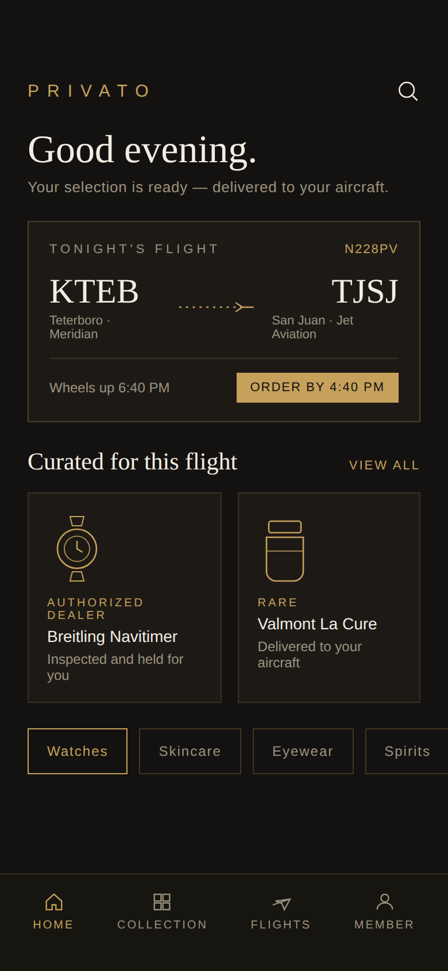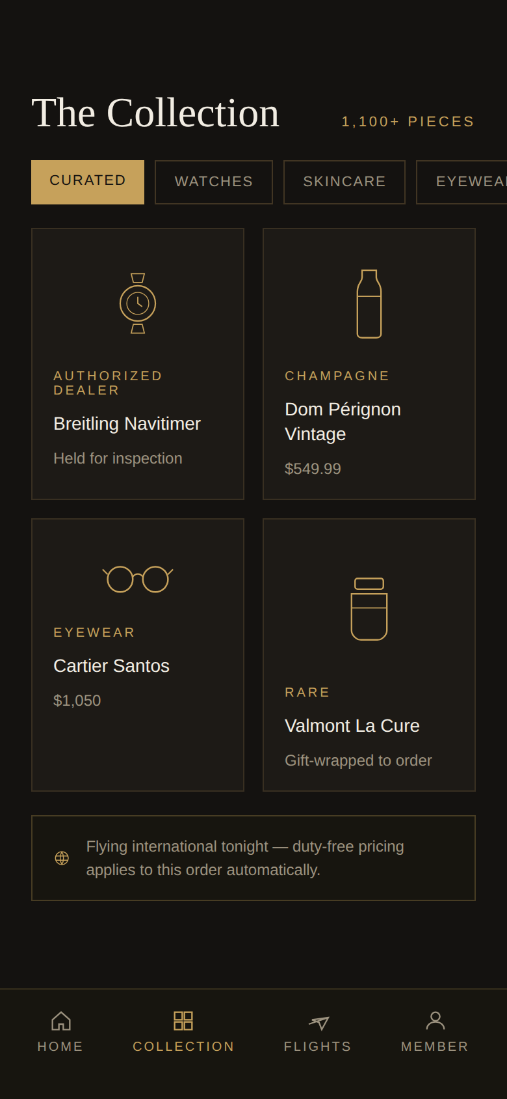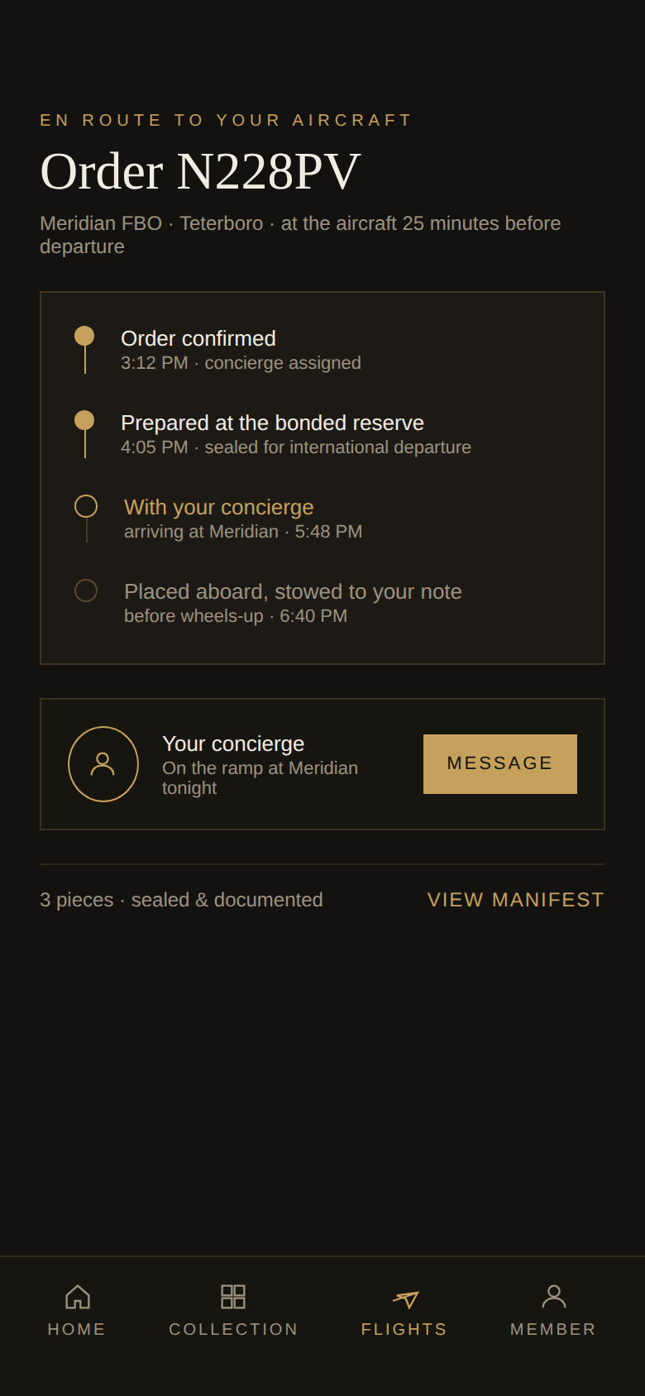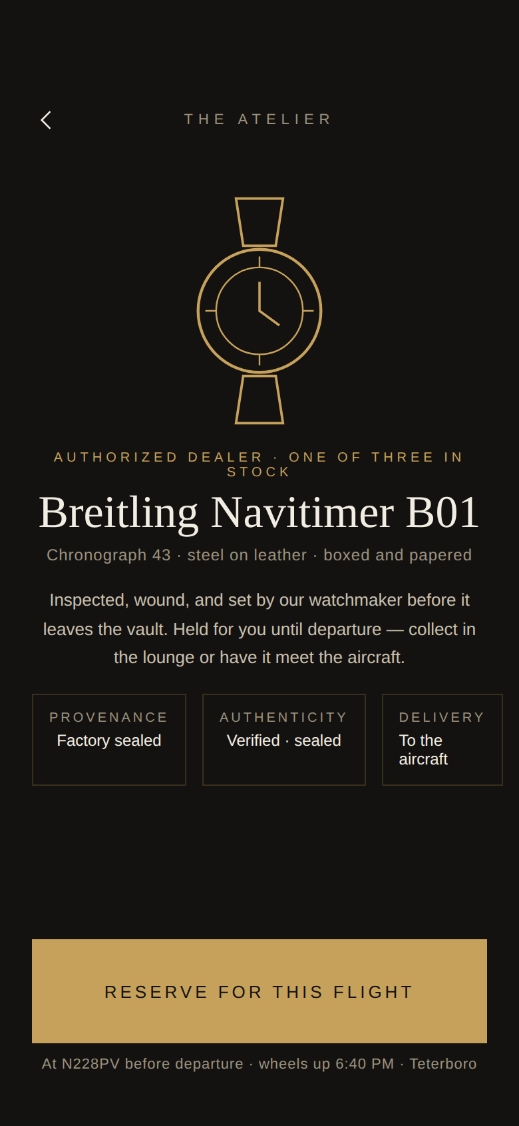
11.2 Website Concept — Homepage and the Private Atelier
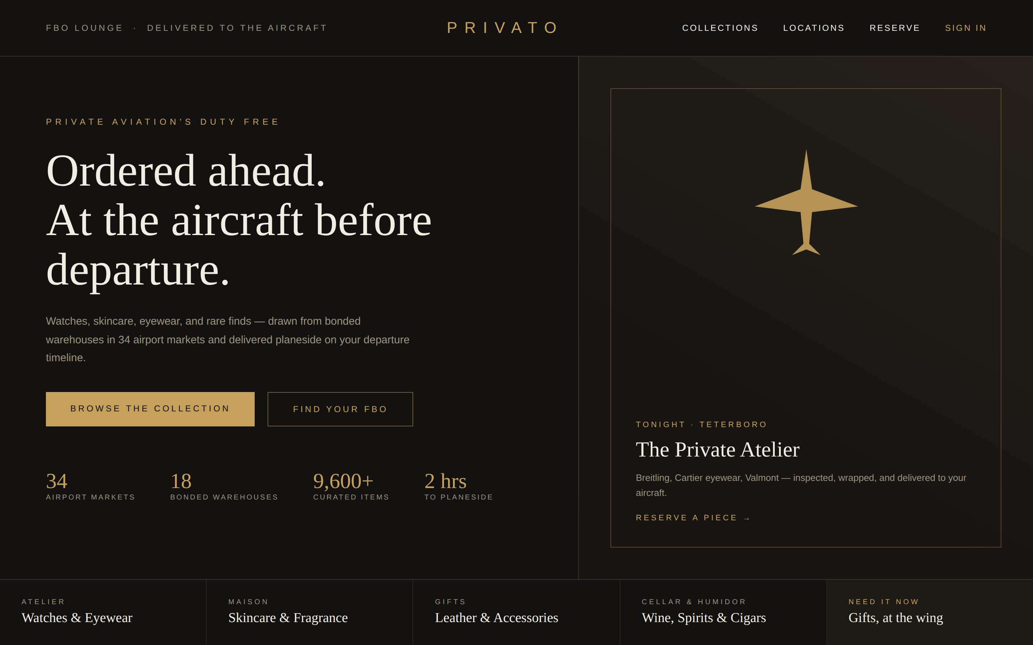
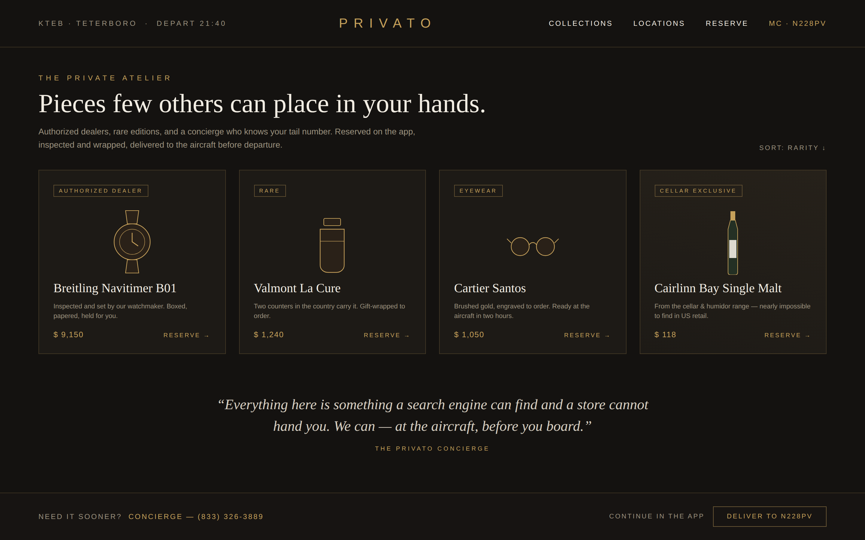

12. Sources and Citations
Every source below was re-checked against the live page on August 27, 2026, and a second corroboration pass then searched for an independent source behind each claim. Primary sources are listed first; corroborating sources follow in each entry. Where no independent second source exists, the entry says so.
12.1 Company Record and Trade Press
- Florida Division of Corporations (Sunbiz) — Bulldog Duty Free Inc., document P17000017404 — corporate record (detail page needs additional confirmation); entity, Dania Beach address, and the Privato DBA corroborated. search.sunbiz.org · dnb.com · bizapedia.com · linkedin.com
- Travel Markets Insider — Streiffer partnership; allocated-bourbon program (Blanton's, Weller, The Last Drop). Distributor identity (Millett Duty Free Inc. dba Dave Streiffer, New Orleans, since 1896) corroborated; the partnership itself is single-source. travelmarketsinsider.net · streifferdutyfree.com
- Travel Markets Insider — New FBO airports; Panama City as the number-three seller — single-source; treat as company-reported until the client confirms. travelmarketsinsider.net
- Travel Markets Insider — Pinehurst festival sponsorship; the 208% event-weekend sales lift — single-source and company-reported; the 2024 US Open context at Moore County is independently confirmed. travelmarketsinsider.net · moorecountyairport.com
- PR Newswire — Lucyd / Innovative Eyewear partnership across seven locations — corroborated by the Tekcapital investor announcement and retail trade press. prnewswire.com · investegate.co.uk · retailitinsights.com
- Moodie Davitt Report / TRBusiness — Duty Free Holdings: $200M 2024 revenue and $500M 2027 target corroborated across both outlets; '21 FBO retail points' reads as announced total (roughly 13 open, the rest planned). moodiedavittreport.com · travelmarketsinsider.net
12.2 Company Web Properties
- Privato storefront — Brand tiles, category pages, and the 1,068-product site catalog; the 9,696-SKU and 34-market figures are company statements with no independent restatement. privatodutyfree.com
- Privato liquor storefront — The 44 live wine and spirits products. privato-duty.myshopify.com
- Streiffer Duty Free — The published brand wall (about 65 of a stated 500+ brands). streifferdutyfree.com
12.3 Aviation and Market Data
- FAA NASR subscription — The 2,442 jet-fuel airports and their positions (APT_BASE dataset; heliports excluded). Fuel specifications are ASTM D1655 (Jet A / Jet A-1); the letter codes in the data are FAA directory service codes, not specifications. faa.gov · nfdc.faa.gov · astm.org
- Golf Monthly / CNBC — The Masters: 2,000+ private jets expected at Augusta Regional in 2026, runway converted to jet parking — corroborated. golfmonthly.com · cnbc.com · golfpost.com
- Business Jet Traveler — Kentucky Derby week: 1,400+ business-aviation flights; Atlantic's record 812 landings (2022 record year) — the record-crowd framing corroborated by AIN and Atlantic Aviation. bjtonline.com · ainonline.com · atlanticaviation.com
- Private Jet Card Comparisons — Super Bowl private-jet history; 900+ day-after departures Phoenix 2023 (Forbes puts it above 950); Flexjet's Oakland pop-up terminal confirmed. privatejetcardcomparisons.com · forbes.com · frontofficesports.com
- Las Vegas Review-Journal — F1 Las Vegas: 272 Henderson and 115 North Las Vegas pre-race reservations — no independent second count found; the parking crunch itself is widely reported. reviewjournal.com
- NFL Football Operations / NBC LA — Super Bowl LXI (Los Angeles 2027) and LXII (Atlanta 2028) host sites. operations.nfl.com · nbclosangeles.com
- Aspen Times — Private aviation at roughly three quarters of Aspen flights — corroborated at ~76-80% of operations. aspentimes.com · aspenjournalism.org
- Wellington International / NetJets — Winter Equestrian Festival: 13 weeks January-March confirmed; NetJets listed as a Wellington International partner. wellingtoninternational.com · thepalmbeaches.com · horseshowjumping.tv
- NBAA — NBAA-BACE 2026 dates and the Henderson static display. nbaa.org
- Breeders' Cup — 2026 Keeneland and 2027 Belmont Park host selections. breederscup.com · nyra.com
- Ryder Cup / Airshare / WingX — 2029 Hazeltine; Bethpage 2025 benchmark — WingX counted 2,220+ private-jet arrivals into the New York area over the event weekend. rydercup.com · privatejetcardcomparisons.com
- The Hollywood Reporter — The 2026 Oscars gifting program valued around $350,000 — corroborated. hollywoodreporter.com · deseret.com · nbclosangeles.com
- Sun Valley / Allen & Co — 160-190 jets during conference week — Quartz independently reported 165. aol.com (Fortune) · qz.com
- Teton County wealth — Highest per-capita income county in the US — BEA county data: $471,751 (2023), $532,903 (2024). bea.gov · wyofile.com · fred.stlouisfed.org
12.4 Partnership Candidates
- Flexjet, Jet Linx, Sentient, NetJets — Formal partner-program intake pages — Globe-Trotter collaboration, the Oct 2025 Jet Linx relaunch, Sentient's Derby role and 2025 Benefits Guide, and NetJets' Art Basel partnership all independently corroborated. flexjet.com · jetlinx.com · sentient.com · netjets.com · businessairnews.com · kentuckyderby.com · businesswire.com
- Pinehurst Resort / USGA — Brand Partners program (Lexus, Titleist) corroborated by the partners' own announcements. pinehurst.com · hospitality.usga.org · pressroom.lexus.com · golfwrx.com
- JSX — Route network, private-terminal model, fleet, and Cabo San Lucas service corroborated; Cabo launched August 2025 at four flights weekly, daily since November 2025; JetBlue and Qatar Airways stakes confirmed, a United stake is reported but less firmly documented. jsx.com · aeroroutes.com · businesswire.com · inc.com · thecabosun.com · skift.com
- Air Culinaire Worldwide — Global private-jet catering network — 1,800+ airports, 23 owned kitchens plus a partner network. airculinaireworldwide.com · bjtonline.com
12.5 Method Sources (Workbook Data Columns)
- IRS Statistics of Income — ZIP-code income data, tax year 2022 (the latest published as of this report): returns, AGI, and the $200K+ income class behind the 50-mile wealth columns (50 miles captures the metro a field serves — Van Nuys reaches Beverly Hills). irs.gov
- FAA NASR / ATADS — Per-airport annual operations from the last NASR cycle carrying them (August 2024; the FAA removed these fields effective September 5, 2024). An operation is one takeoff or landing — flights are half. Air taxi is defined by aircraft size and for-hire status, not engine type, so it is largely but not purely turbine. nfdc.faa.gov · faa.gov · aspm.faa.gov
- Federal Reserve / Census — Net worth is published only at national level (Survey of Consumer Finances), which is why IRS income data is the standard local wealth stand-in; ZIP centroids from the Census ZCTA gazetteer. federalreserve.gov · census.gov
- US Customs (eCFR) — 19 CFR 19.36: conditionally duty-free merchandise may be delivered only to individuals departing the customs territory — the rule behind the international-departures-only limit. ecfr.gov · cbp.gov
Corrections from the corroboration pass, applied in the companion workbook and carried through the current version 0.10.0: Air Culinaire's network updated to 1,800+ airports; the Ryder Cup benchmark updated to WingX's actual 2,220+ arrivals; Duty Free Holdings' shop count qualified as announced-vs-open; JSX's Cabo cadence and investor list tightened; and the air-taxi turbine characterization qualified. Warehouse counts in trade coverage grew from 12 (2023) to 18 (March 2025) — read as network growth, confirm the current figure with the client. Claims resting on a single trade-press report or company statements (Panama City ranking, the 208% lift, SKU and market counts) remain flagged as needing additional confirmation rather than treated as established.

